**Accessing Frontend: Fibonacci Calculator**

Test Scenarios:

Using valid URL

Using invalid URL

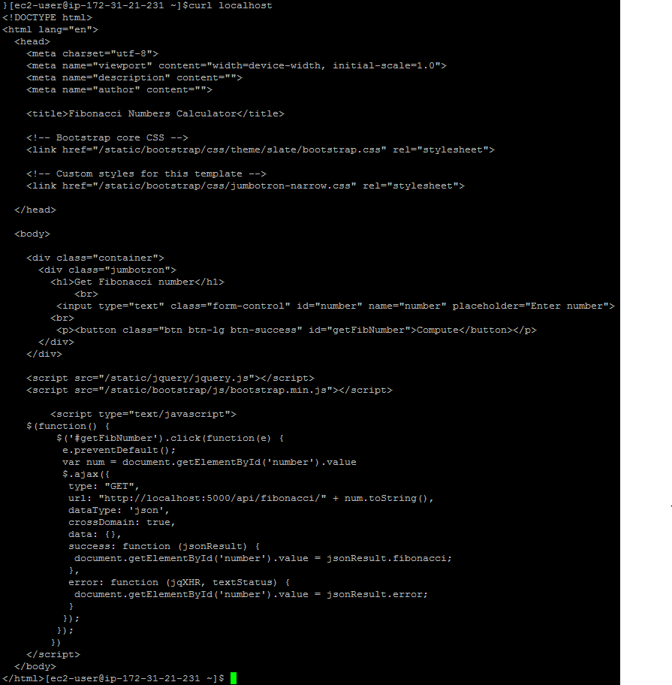

<http://ec2-52-35-41-144.us-west-2.compute.amazonaws.com/>

***Note: The host name is not persistent so it might change as the IP address is not static***

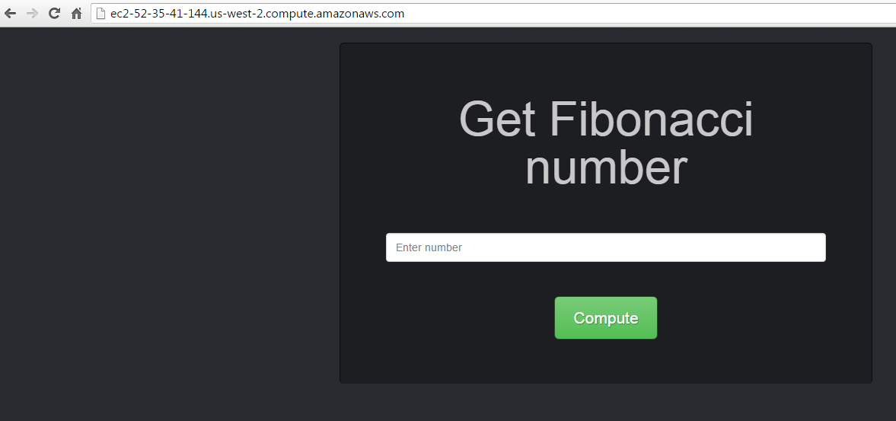

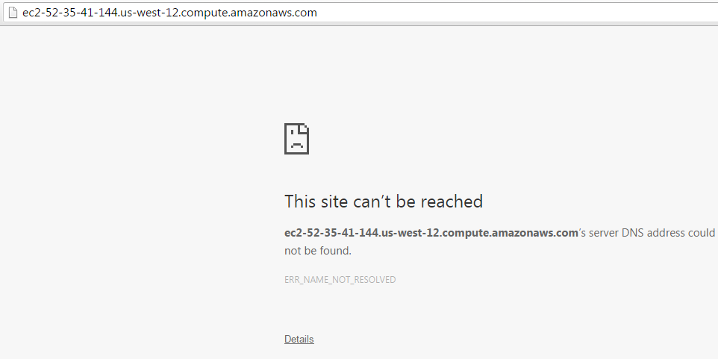

**Accessing Backend:**

Test Scenarios:

Passing valid Fibonacci numbers

Passing strings character instead of numbers

Passing numbers over 46, 47, 48, 79 and 90

Passing negative numbers

Passing special characters

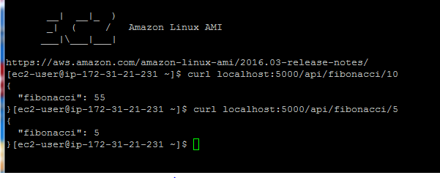

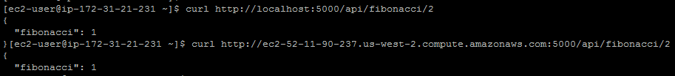

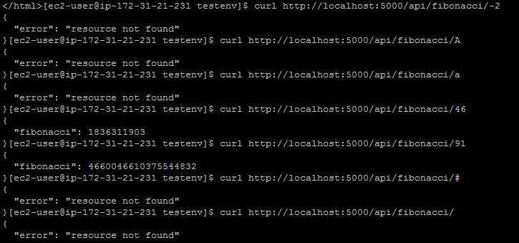

**Test Run Result:**

Front end:

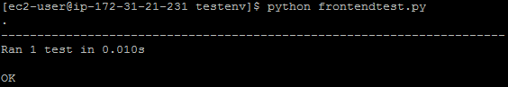

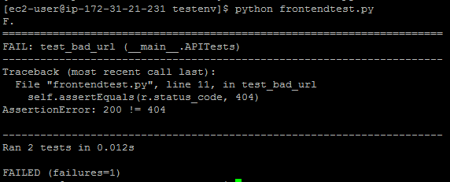

***Note: The host name is not persistent so it might change***

When the URL changes and if I run the old test case the test case fails

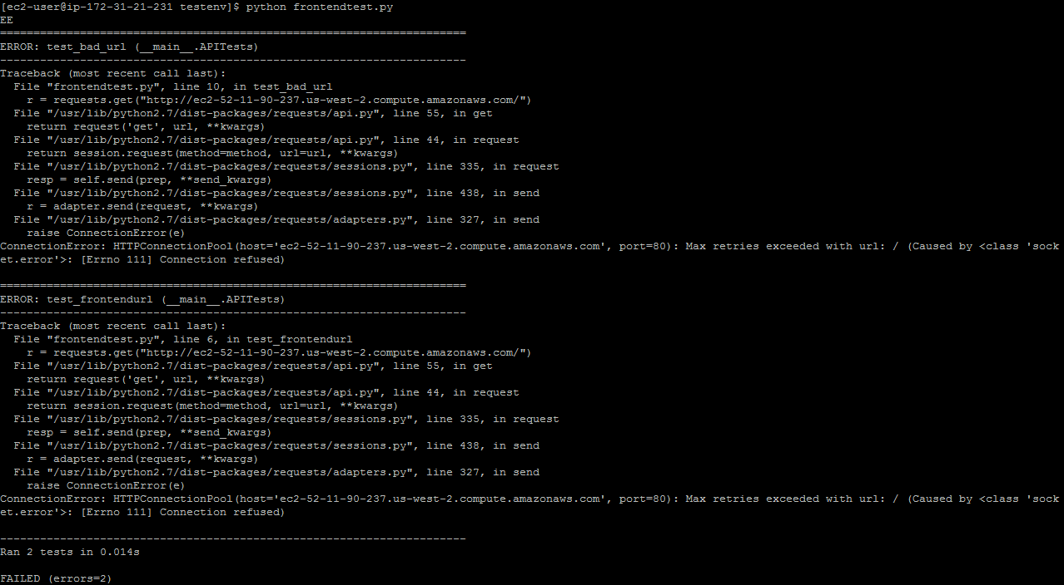

Backend Testing Result:

